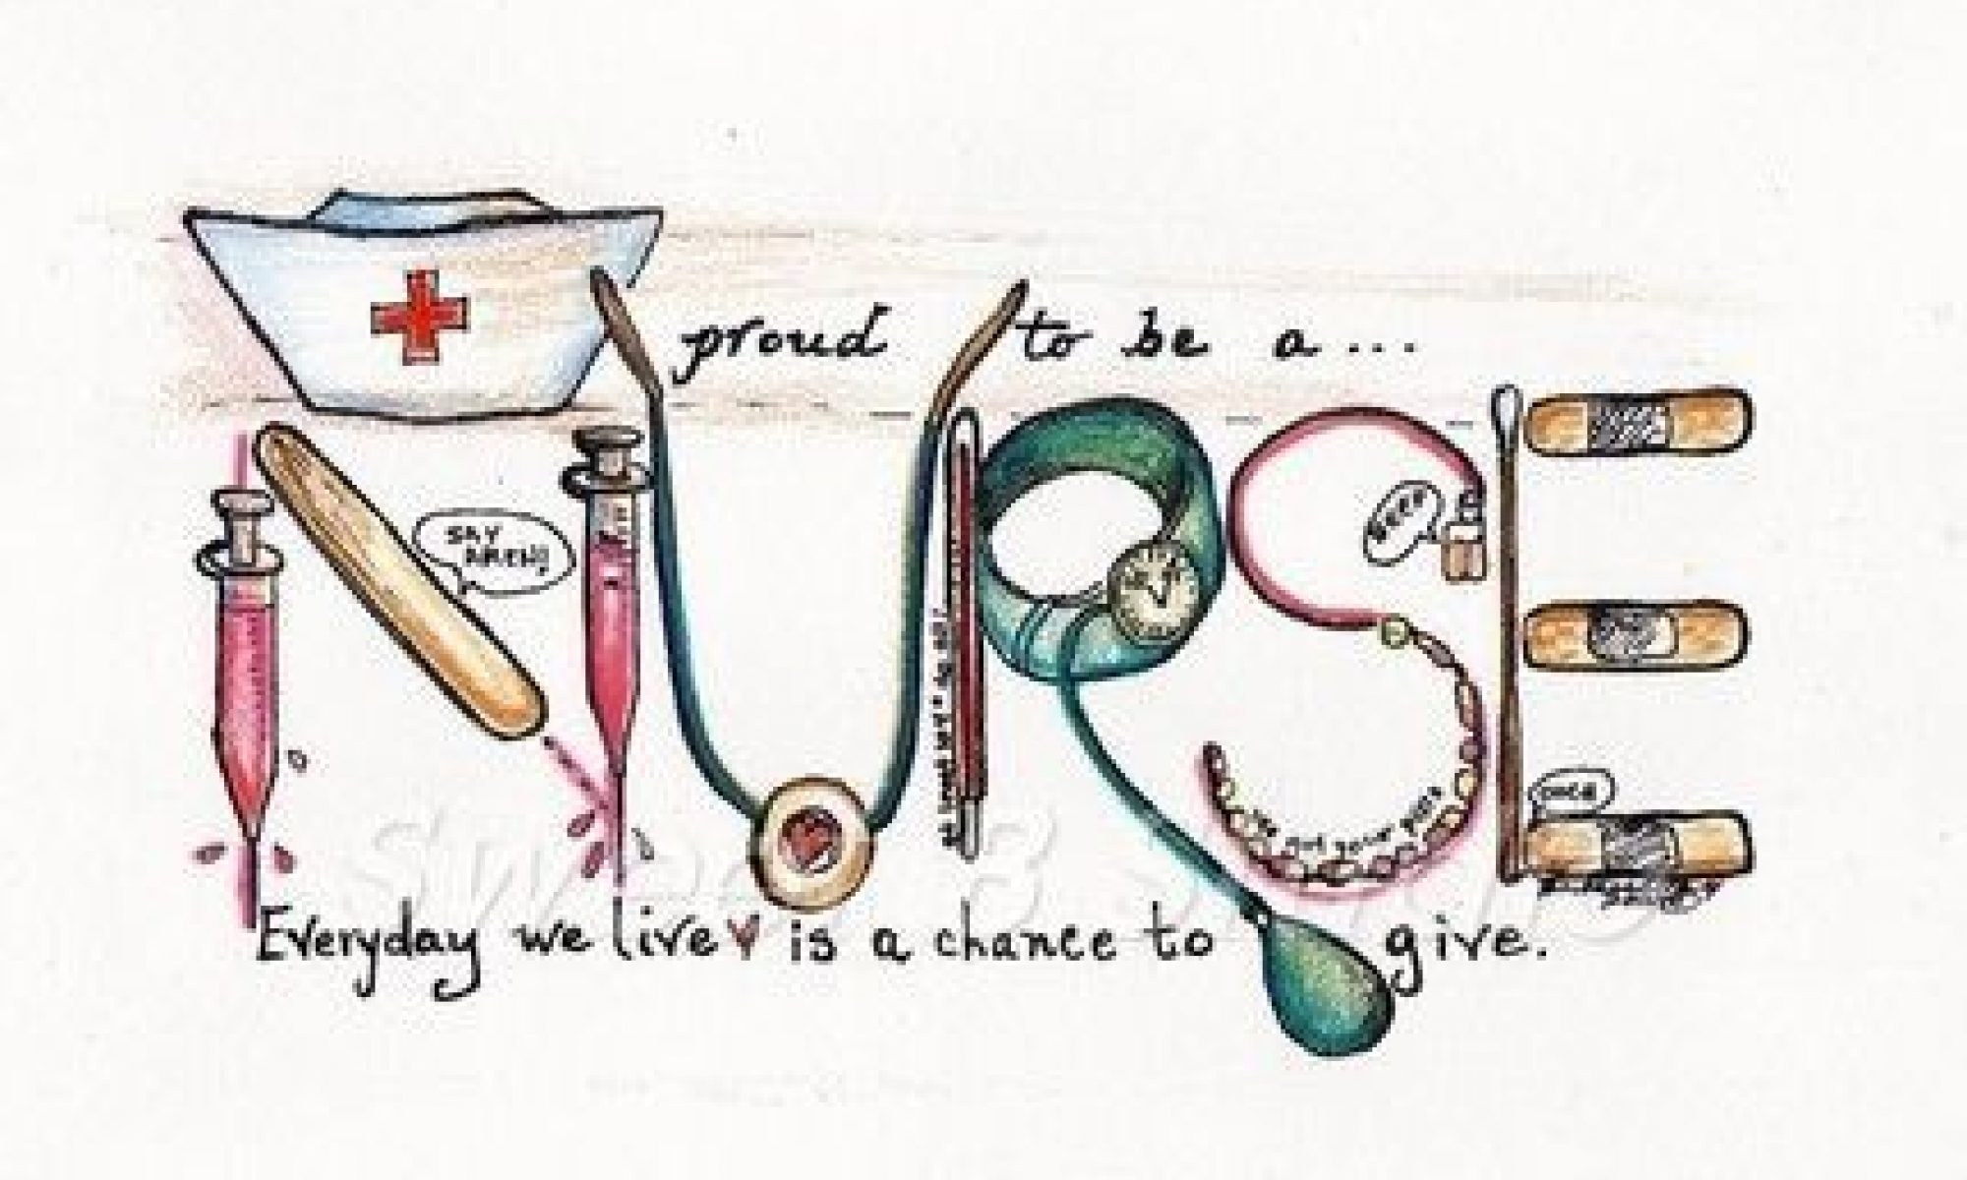

Student Handbook
Ashover Ward
An induction to General Medicine
Louise Turner – Learning Environment Manager (LEM)

Ashover Ward
Ashover ward is a 32 bedded ward for general medicine that specialises in Dementia and Parkinsonism. All staff on Ashover ward has undergone training on dementia, we promote dignity and patient choice. We provide good nutrition and hydration by giving assistance, patience and understanding. We are committed to providing patient-centred care that is delivered with kindness and compassion.
We have three consultants who all specialise in care of the elderly.. Each consultant has a team of Drs that they lead.
Also in the MDT are physiotherapists, occupational therapists, dieticians, social worker, speech and language therapists, porters, domestics, house keeper.

Welcome to team Ashover.
Working hours
Morning 07:00-14:30
Afternoons 12:00-19:30
Long day 07:00-19:30
Long night 19:00-07:30

You will be allocated an Assessor and supervisors .You will be orientated to the ward area on your first day of placement .Trust policies are available on the intranet and you should familiarise yourself with them, in particular infection control policies.
Your supervisor is there to support you and facilitate LEARNING OPPORTUNITIES. You should also take responsibility for your own learning, identifying and learning needs, opportunities’ and utilizing the support available. Please collect any evidence which will aid you and your Assessor in completing your proficiencies.
The off duty will be completed and available in the Off-Duty folder. Changes to the off duty should be documented and signed by a staff member. Please don’t change the off duty without consent from mentor or LEM (Learning Environment Manager).
Please inform the nurse in charge or assessor if you are unable to attend placement and when you’ll be “fit”. It is also your responsibility to inform the University of any Sickness, as per University policy.
If you have any concerns regarding your placement, please speak to your assessor. If they are not available, please speak to the LEM, matron or sister on the ward, or if there are any issues when you feel unable to speak to your supervisors or assessor.

Matron: Roselyn Blake

Learning Environment Manager: Louise Turner louise.turner18@nhs.net

Ashover Ward Contact number: 01246 512410/512411

We hope that you enjoy your time with us, and please let us know if there is anything you need or request during your placement.

Medical Conditions

Angina
Asthma
Cancer
Cellulitis
Chest Infection
Chronic Obstructive Pulmonary Disease (COPD)
Confusion
Deep Vein Thrombosis (DTV)
Dementia
Diabetes Mellitus
Gastroenteritis
Mechanical Falls
Myocardial Infarctions (MI)
Parkinsons
Rheumatoid Arthritis
Sepsis
Stroke
Transient Ischaemic Attack (TIA)
Urinary Tract Infection
Vasculitis

Abbreviations explained…

AAA | Abdominal Aortic Aneurysm
ABG | Arterial Blood Gas
ACS | Acute Coronary Syndrome
AF | Arterial Fibrillation
AKI | Acute Kidney Disease
AVR | Aortic Valve Replacement
BM | Blood Glucose Monitoring
BTHR | Bilateral Total Hip Replacement
BTKR | Bilateral Total Knee Replacement
C-DIFF | Clostridium Difficile
Ca | Cancer
CABG | Coronary Artery Bypass Graft
CBD | Catheter Bag Drainage
CCF | Congestive cardiac Failure
CKD | Chronic Kidney Disease
CLL | Chronic Lymphocytic Leukaemia
COPD | Chronic Obstructive Pulmonary Disease
CSU | Catheter Stream Urine
CT | Computerised Tomography
CXR | Chest X-Ray
D&V | Diarrhoea & Vomiting
DST | Decision Support Tool
DVT | Deep Vein Thrombosis
ESBL | Extended Spectrum Beta-Lactamases
Exac | Exacerbation
GORD | Gastro-oesophageal Reflux Disease
Hb | Heamaglobin
HTN | Hypertension
IHD | Ischaemic Heart Disease
INR | International Normalised Ratio
IVAB | Intravenous Antibiotics
IVI | Intravenous Fluids
K | Potassium
L&S BP | Lying and Standing Blood Pressure
LAKA | Left Above Knee Amputation
LTKR | Left Total Knee replacement
LVF | Left ventricular Failure
MI | Myocardial Infarction
MR | Mitral Regurgitation
MRSA | Methicillin Resistant Staphylococcus Aureus
MSSA | Methicillin Sensitive Staphylococcus Aureus
MSU | Mid-Stream Urine
Na | Sodium
NBM | Nil By Mouth
NH | Nursing Home
NOF | Neck of Femur
NSTEMI | Non ST Elevation Myocardial Infarction
OA | Osteoarthritis
OPA | Out Patient Appointment
PAF | Paroxysmal Atrial Fibrillation
PE | Pulmonary Embolism
POP | Plaster of Paris
PVD | Peripheral Vascular Disease
RA | Rheumatoid Arthritis
RH | Residential Home
SALT/SLT | Speech and Language Therapist
SDH | Subdural Haematoma
STEMI | ST Elevation Myocardial Infarction
TIA | Transient Ischaemic Attack
TVN | Tissue Viability Nurse
TWOC | Trial Without Catheter
UTI | Urinary Tract Infection
XR | X-Ray
# | Fracture

What is Dementia?
Dementia is a non-reversible decline in cognitive ability and memory loss. It is caused by damaged caused to the brain through disease; such as vascular Dementia, Mixed dementia, Dementia with Lewy Bodies, Frontotemporal Dementia, Alzheimer’s disease, and Strokes. The diseases cause progressive damage to the brain, therefore impacting their daily lives. Around 800,000 people living in the UK suffer from dementia, which explains the importance of patient-centred care, dignity and compassion when nursing these patients.
For more information, please take a look at www.alzheimers.org.uk
What is Parkinson’s disease?
Parkinson’s disease is a neurological disorder that is diagnosed only after enough traits of the disease are noticed to be present. Some of these traits are: slowness; stiffness; tremor; postural instability; freezing after taking steps; inability to show expression on their face; and unable to perform small motor-function tasks such as buttons and small objects. When the traits are developed, the individual is at high risk of falls and injuries due to these traits. Parkinson’s does not cause damage to the brain, although it may be that Dementia is also present. This should not be confused with symptoms of depression and slow speech that is recognised as Parkinson traits.
For More Information, please visit www.parkinsons.org.uk

The next four pages are for you to test your knowledge on a few medical conditions.

What are the symptoms of Parkinson’s disease, and how is it diagnosed?
What is Parkinson’s disease?

Who is at risk of Parkinson’s?
Is a patient with Parkinson’s disease more susceptible to falls, and why?

Parkinson’s Disease – What do you know?
What other members of the multi-disciplinary working should we liaise with?

How can we help a patient with Parkinson’s disease on the ward?

What are the symptoms of Dementia?
What is dementia, and what are the different types?

What are the changes in the brain?

Dementia – What do you know?
Who can develop dementia?

What can we do to help someone with dementia, while they are in hospital?
What is the ‘This is me’ document?

Can you recognise anything on the ward that may help people with dementia?

Which is the most common dementia?

What does COPD stand for?
Who will get COPD?
What Causes COPD?

What are the symptoms of COPD?

What advice and education should the COPD patient receive when in hospital?

What treatments do we give COPD?
COPD – What do you know?

What do we need to remember when using oxygen therapy in the COPD patient ?

Explain why the NEWS chart for patients with COPD scores differently and why?

How many types of diabetes are there? What are they and what is the difference?
Where in the body is insulin made?
What is a Hypo?
What is blood glucose?
What might happen to a patient if they have a Hyper?

How is each type of diabetes treated?
What might happen to a patient if they have a hypoglycaemic episode?
Who is the best person to administer a patient’s insulin? Why?
What is a Hyperglycaemia ?
What causes diabetes?
Diabetes: What do you know?

